Air-fare booking system Project proposal
  - Dec 08, 2025

group members SAP ID# ROLES
- Syed Mubazir Haider – 70174586 - Lead Developer
- Abdul Moez – 70172118 - Database Architect
- Aleeza Bibi – 70172057 - Front-End Developer
- Moiz Rizwan – 70173658 - System Designer
- Urwa Iqbal – 70176179 - UI/UX Developer

Project Overview
This project focuses on developing an online Airplane Ticket Booking System that enables users to search for flights, check availability, and book tickets efficiently. It streamlines the reservation process by eliminating manual paperwork and long queues. The system allows users to view flight options and make secure bookings. Overall, it aims to provide a fast, user-friendly, and efficient platform for managing air travel reservations for both passengers and airlines connected to the system.

Project Objectives
The system includes the following:
- To provide an easy-to-use platform for searching, selecting, and booking flights.
- To automate the entire ticket reservation process, reducing manual errors and workload.
- To provide real-time information on flight schedules, seat availability, and pricing.
- To store and manage passenger details and booking records efficiently.

Project Scope
The scope of the Airfare Booking System includes, but is not limited to:
- Flight Search: Provides real-time flight search with schedules and prices.
- User Management: Handles user registration and secure login.
- Booking Module: Manages booking, seat selection, and ticket generation.
- Payment Integration: Processes payments via external gateways.
- Tickets Module: Allows users to view, modify, and cancel bookings.
- Passenger Records: Stores passenger and booking information.
- Airline Administration: Lets airlines manage flights, schedules, and seats.
- System Administration: Controls roles, permissions, and system logs.

OOP Concepts to Be Used
The Airfare Booking System will use OOP concepts like classes and objects to represent entities, encapsulation to protect data, and inheritance and polymorphism for different user types. Abstraction will simplify complex operations, while composition and association will manage relationships between entities. Constructors and destructors will initialize objects with default or user-provided values and handle cleanup when needed. Function overloading and overriding will ensure flexible and consistent functionality throughout the system.

Tools & Technologies
- Dev-C++ Coding & Development
- MySQL Database Server & Storage
- C/C++ Programming Language
- SQL Database Query Scripting
- draw.io System Design & Database Architecture
- C.L.I Application Interface

Prototype 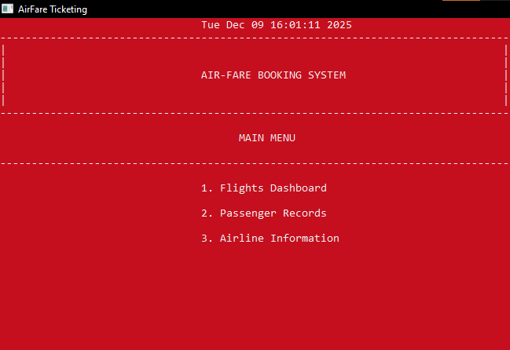

Flowchart

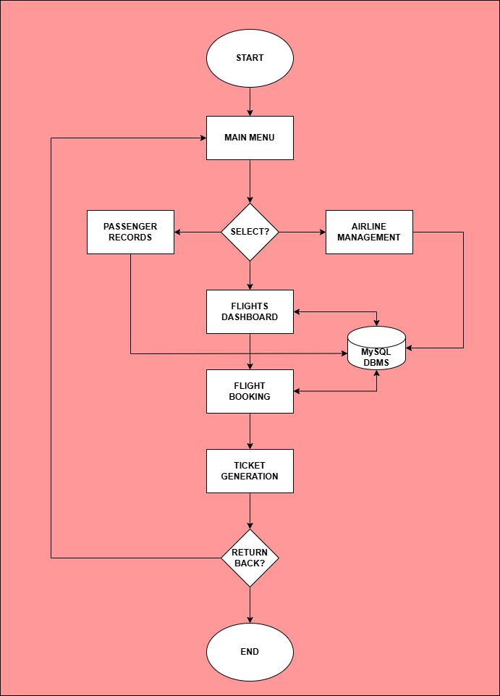

Use Case Diagram

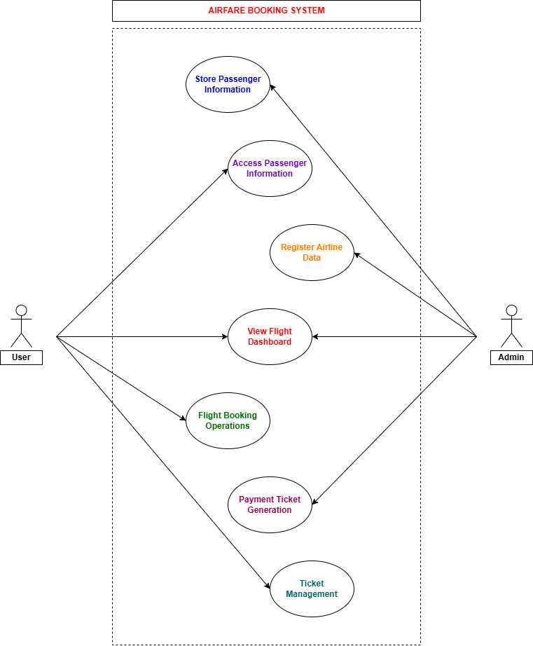

END OF DOCUMENT

